ITA0610 - Machine Learning
EXP-1
1.Implement and demonstrate the FIND-S algorithm for finding the most specific hypothesis based on a given set of training data samples.
Experiment: FIND-S Algorithm
Aim
To implement and demonstrate the FIND-S algorithm for finding the most specific hypothesis from a given set of training data samples.
Algorithm
- Start with the most specific hypothesis h.
- Read the training dataset.
- For each training example:
  - If the example is positive (Yes):
    - Compare each attribute with the hypothesis.
    - If the hypothesis attribute is empty, replace it with the training value.
    - If the values differ, replace that attribute with '?'.
  - Ignore negative examples.
- Repeat until all training examples are processed.
- Display the final hypothesis.
Python Program

data = [
['Sunny', 'Warm', 'Normal', 'Strong', 'Warm', 'Same', 'Yes'],
['Sunny', 'Warm', 'High', 'Strong', 'Warm', 'Same', 'Yes'],
['Rainy', 'Cold', 'High', 'Strong', 'Warm', 'Change', 'No'],
['Sunny', 'Warm', 'High', 'Strong', 'Cool', 'Change', 'Yes']
]

hypothesis = ['0'] * (len(data[0]) - 1)

print("Initial Hypothesis:")
print(hypothesis)
for example in data:
if example[-1] == "Yes":
for i in range(len(hypothesis)):
if hypothesis[i] == '0':
hypothesis[i] = example[i]
elif hypothesis[i] != example[i]:
hypothesis[i] = '?'

print("\nFinal Hypothesis:")
print(hypothesis)

OUTPUT:
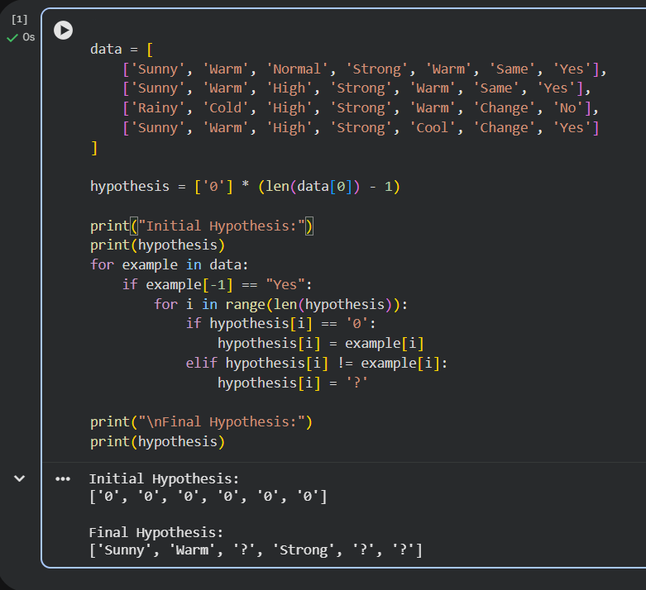

Result
The FIND-S algorithm was successfully implemented. It identified the most specific hypothesis that correctly classifies all positive training examples.

